Dis-Eur-Czech-Těšetice-Kyjovice-Venus figurines

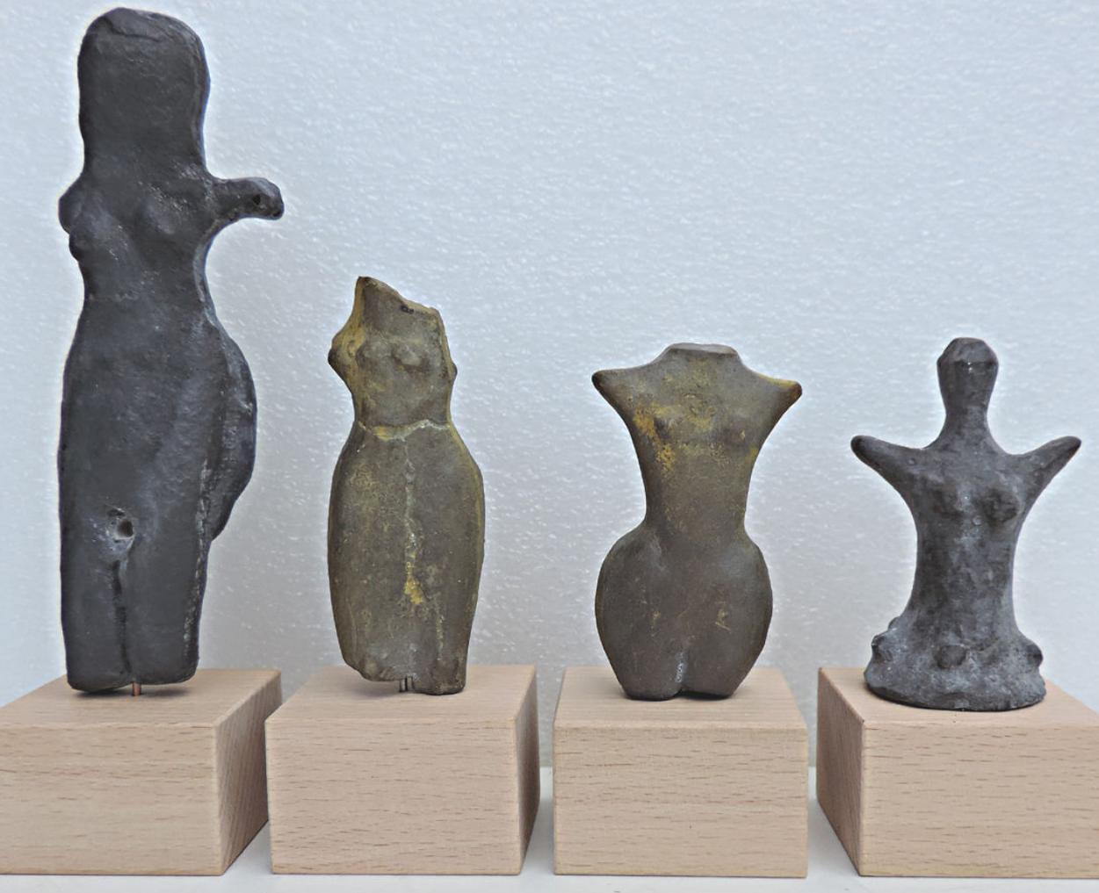

Formal Label: Venus Figurines, Czech Republic, Moravia, **Těšetice-Kyjovice-**4,600 – 4,400 BCE

Accession Number:

**LC Classification:** N5310,A1

Date or Time Horizon: 4,600 – 4,400 BCE

**Age:** Neolit - about 4 600 - 4 400 Years BC  
**Size of greatest Venus: 13 cm (5,1 inches).  
Material of original: Baked clay.**

**from Těšetice-Kyjovice -** casts of resin.

Geographical Area: Czech Republic, Moravia

Cultural Affiliation: **Těšetice-Kyjovice**

Medium: Originals baked clay; reproductions casts of resin.

Dimensions: Figure on left 13 cm (5.1 in)

Weight:

Provenance:

Discussion:

References:

.